OBJECTIVE QUESTIONS

Question 1: What is the total no. of attributes present in the data?

Solution:

Final Answer (if any):
15 attributes in raw dataset & 14 after data processing
Approach (if any):
Counted the number of column names present
Charts & Tables (if any):
- Table / Chart Name: Tickets, IT agents, cleaned data

Question 2: Which columns have inconsistent or missing values, and what is the count of such values?

Solution:

Final Answer (if any):
Mayor to major 4836 replacements were done, unclasified to unclassified 356 replacements were done, unassiged to unassigned 29410 replacements were done and Fecha to date was changed and the name of the agent is also inconsistent retrieved the correct full name of the agents.

Approach (if any):
Scanned categorical columns for:
Spelling errors & Unexpected categories, Identified "Mayor" as inconsistent with "Major" and “Unclasified” as inconsistent with “Unclassified”
Used Find & Replace to change the values
Charts & Tables (if any):
- Table / Chart Name: - Tickets , Cleaned data

Question 3: What is the average daily ticket volume over time?

Solution:

Final Answer (if any):
Average daily ticket volume ≈ 53 tickets per day
Approach (if any):
Created a Pivot Table with Date (Fecha) in Rows and Count of ID Ticket in Values to get daily ticket counts.
Then calculated the average using:
Total Tickets ÷ Total Number of Days
Charts & Tables (if any):
- Table / Chart Name:
Daily Ticket Volume
- Description:
Shows number of tickets per day; the average of this daily count represents the average daily ticket volume over time.

Question 4: What is the distribution of ticket categories (e.g., Login Access, System, Software)?
Hardware | 9733
Login Access | 29193
Software | 19570
System | 39002

Solution:

Final Answer (if any):

Approach (if any):
Grouped data by Request Category
Counted number of tickets in each category using:
Pivot Table Rows → Request Category, Values → Count of Ticket
Compared counts to identify distribution pattern
Charts & Tables (if any):
- Table / Chart Name:
Distribution of Tickets by Category
- Description:
This chart visually represents the proportion of tickets across different categories. It highlights that system issues account for the highest no of tickets, followed by login access, while hardware had the least. System-related issues dominate the ticket volume, indicating a need for system stability improvements or monitoring.

Question 5: How many tickets has each agent handled?

Solution:

Final Answer (if any):
Each agent has handled approximately 1,850 to 2,030 tickets.
The highest tickets handled ≈ 2027 (Aurelio Tanori)
The lowest tickets handled ≈ 1856 (Griselda Galindo)
This shows a fairly balanced workload distribution among agents.
Approach (if any):
Created a Pivot Table. Placed Agent Name in Rows. Placed Ticket ID in Values (set to Count).
This calculates the total number of tickets handled by each agent. Sorted the values to identify agents who handled highest and least tickets.
Charts & Tables (if any):
- Table / Chart Name:
Agent-wise Ticket Handling
- Description:
This table shows the total number of tickets handled by each agent. It helps evaluate individual workload distribution and identify top-performing and underperforming agents.

Question 6: How can you extract the domain from the email addresses in the IT Agents sheet?

Solution:

Final Answer (if any):
The domain from email addresses can be extracted using the formula:
=RIGHT(C3, LEN(C3) - FIND("@", C3))
Approach (if any):
Used the FIND("@", C3) function to locate the position of "@"
Used LEN(C3) to get the total length of the email
Applied RIGHT() to extract all characters after "@"
Dragged the formula down to extract domains for all email entries
Charts & Tables (if any):
- Table / Chart Name:
IT Agents Sheet
- Description:
All agents belong to the same domain (fp20analytics.com), indicating a centralized organizational email system.

Question 7: How can you find the full name of an agent given their Agent ID?

Solution:

Final Answer (if any):
First extracted name from the email and separated the first and last name from that and combined first and last name using concatenate.
full name of agent retrieved into Tickets sheet using this formula
=XLOOKUP([@[Agent ID]],IT_Agents[Agent ID],IT_Agents[Agent Full Name]) Approach (if any):
First extracted name from the email and separated the first and last name from that and combined first and last name using concatenate to get the full name of the agent.

Used Agent ID as the lookup value
Referred to the IT Agents sheet where:
Column A = Agent ID, Column B = Agent Name
Applied XLOOKUP to: Search for Agent ID in Column A, Return the corresponding Agent Name from Column B.
Dragged the formula down to populate names for all records
Charts & Tables (if any):
- Table / Chart Name:
Tickets, IT Agents, cleaned data
- Description:
This links each Agent ID with its corresponding full name. It is used to identify which agent handled each ticket and ensures proper tracking and reporting of agent performance.

Question 8: What is the count of each issue type (e.g., IT Error, IT Request)?

Solution:

IT Error | 24278
IT Request | 73220
Final Answer (if any):

Approach (if any):
Created a Pivot Table
Placed Issue Type in Rows, Placed Ticket ID in Values (set to Count)
This calculated the total number of tickets for each issue type
Charts & Tables (if any):
- Table / Chart Name:
Issue Type Ticket Distribution
- Description:
A table that compares the number of IT Errors and IT Requests, highlighting that IT Requests dominate the overall ticket volume. A significantly higher number of IT Requests suggests that most tickets are service-related rather than error-based, indicating operational demand rather than system failures.

Question 9: What is the average resolution time for tickets?

Solution:

Final Answer (if any):
The average resolution time for tickets is approximately 4.55 days.
Approach (if any):
Created a Pivot Table
Placed Resolution Time (Days) in Values, Set the aggregation to Average
To analyze trends, added Month in Rows
Charts & Tables (if any):
- Table / Chart Name:
Avg Resolution Time Trend
- Description:
This table displays the average number of days required to resolve tickets. It includes both the overall average and a monthly breakdown, helping identify trends and variations in resolution efficiency over time.

Question 10: How has the volume of tickets changed over time?

Solution:

Final Answer (if any):
The volume of tickets shows a generally stable trend over time with minor fluctuations across months. There are slight increases in certain months, but no extreme spikes or drops, indicating consistent ticket inflow throughout the year.
Approach (if any):
Created a pivot table
Placed month in rows, placed ticket ID in values (set to Count)
Analyzed the variation in ticket counts over time
Charts & Tables (if any):
- Table / Chart Name:
Ticket volume over time
- Description:
Line chart illustrating the trend of ticket volume across months. It helps identify patterns such as peak periods, low activity phases, and overall consistency in ticket generation.

Question 11: What is the average age of the IT agents?

Solution:

Final Answer (if any):
The average age of the IT agents is 40.62 years.
Approach (if any):
Calculated Age:
Used formula to compute age for each agent.
Excel formula =DATEDIF(DATE([@[Year of Birth]],[@[Month of Birth]],[@[Day of Birth]]),TODAY(),"Y")
Computed Average Age: Created a Pivot Table
Placed AGE in Values, Set the aggregation to Average
Charts & Tables (if any):
- Table / Chart Name:
Avg age of agents
- Description:

Question 12: Is there a correlation between the severity of issues and the resolution time?

Solution:

Final Answer (if any):
There is no strong linear correlation between issue severity and resolution time. Instead, the relationship is non-linear and influenced by priority handling, urgent issues are resolved faster, while normal issues take longer.
Approach (if any):
Created a Pivot Table with Severity as rows and Average Resolution Time (Days) as values. Compared the average resolution time across severity levels to identify trends. Since the values do not follow a consistent increasing or decreasing pattern, the correlation is weak/non-linear.
Charts & Tables (if any):
- Table / Chart Name:
Severity vs Avg Resolution Time
- Description:
The average resolution time for each severity level, highlighting that urgent tickets are resolved faster while normal ones take longer, indicating priority-based resolution rather than direct correlation.

Question 13: How many categorical columns are there in the data? [Search about categorical and continuous data, and try to answer this question]

Solution:

Final Answer (if any):
Total categorical columns in the cleaned data = 6 (request category, issue type, severity, priority, Agent name, Email
Continuous data = 3 ( resolution time, satisfaction rate, age)
Approach (if any):
Identified all columns from both datasets, classified them as categorical or continuous, and counted unique categorical columns
Charts & Tables (if any):
- Table / Chart Name: - cleaned data
- Description: - the final cleaned data

SUBJECTIVE QUESTIONS

Question 1: If there is an investment, should it be used to hire more IT agents, improve training programs, or upgrade ticket management software?

Analysis: Perform a cost-benefit analysis using ticket resolution and satisfaction metrics.

Solution:

Approach:
To decide where to invest, I looked at three key things: how many tickets each agent handles, how long they take to resolve them, how satisfied customers are
Since these are on different scales, I normalized them and gave equal importance to all three. Then I created a performance score to compare agents fairly.
Charts & Tables:
- Table / Chart Name: Agent performance analysis & Agent_performance_ranking

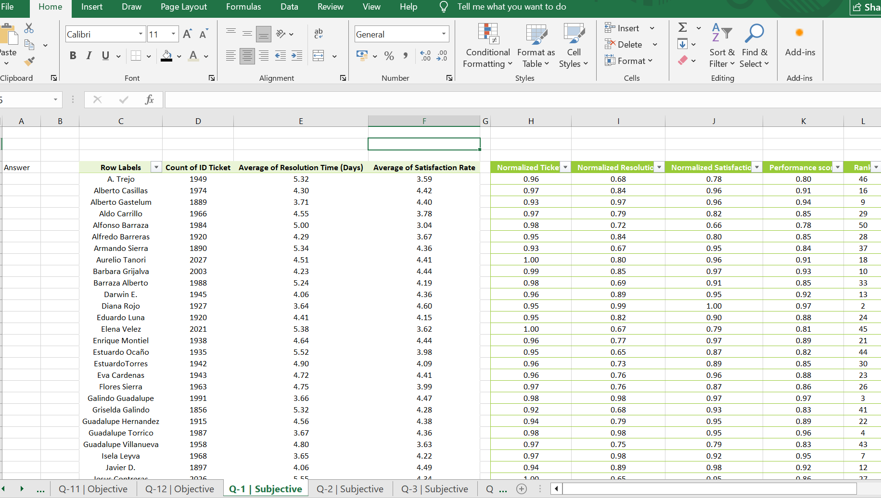

- Description:
This table shows each agent’s workload, efficiency, satisfaction, and overall performance score, making it easy to compare how well each agent is performing.
Insights:
Ticket load is almost the same for all agents so no one is overloaded. But resolution time and satisfaction vary a lot. Some agents are fast and have high satisfaction, while others are slower with lower satisfaction. This shows the issue is not workload, but differences in performance
Recommendations:
Focus on training programs: It will help slower agents improve, reduces resolution time and will improve user satisfaction
Upgrade software: will support faster handling
Hiring more agents is not needed right now because workload is already evenly distributed, and hiring more agents can reduce the workload and reduce the delays also. And the main problem is how efficiently agents work, not how many agents there are. Investing in training and some software improvement will give best results and focus on hiring agents later.

Question 2: Which agents need additional training based on their performance metrics?

Analysis: Identify agents with the lowest satisfaction ratings and longest resolution times.

Solution:

Approach:
I used a pivot table to look at each agent’s average resolution time and satisfaction. Then I created a new column using an IF condition to mark agents who:
take more time than the average and have lower satisfaction than the average
After that, I filtered only the agents marked “Yes” to find who needs training. All the agents with training yes need training and the bottom 8 need more training guidance and monitoring so that they can improve fast.
Charts & Tables:
- Table / Chart Name:
Agents performance review and bottom 8 performers

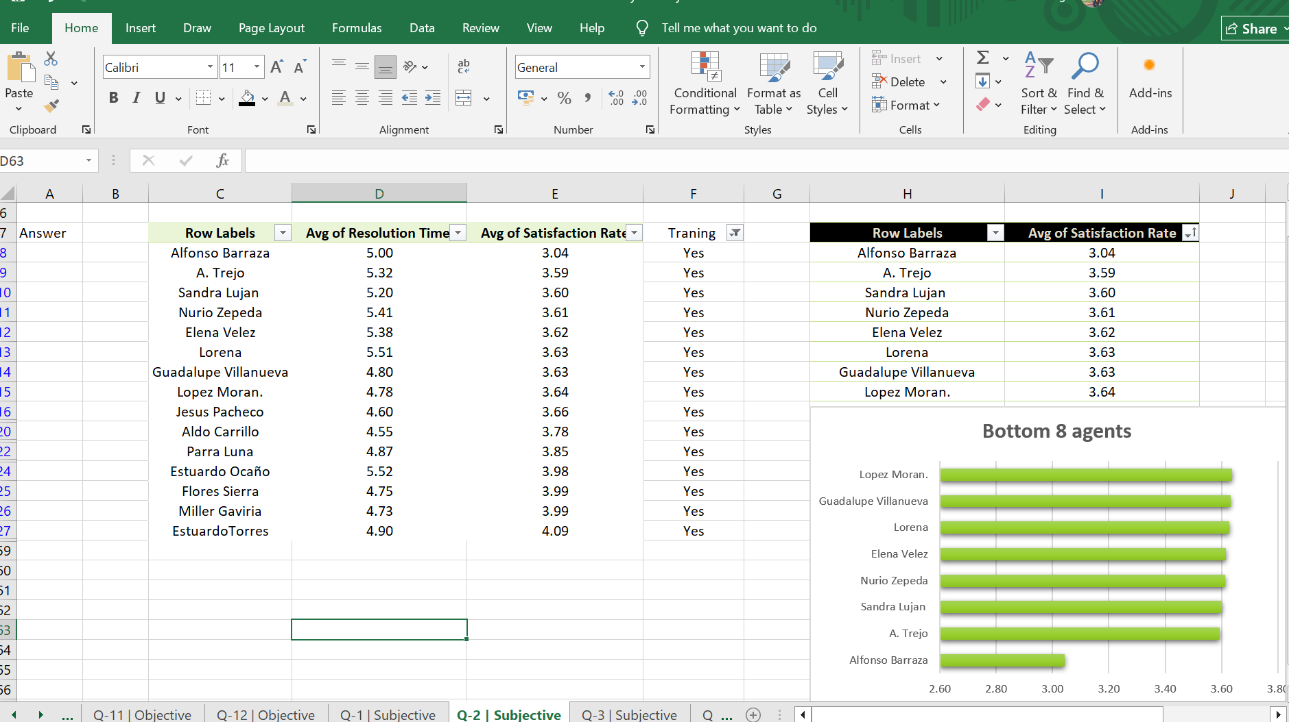

- Description:
This table shows each agent’s avg resolution time, satisfaction rate, and whether they need training based on the condition. and the bottom agents how need training and upskilling
Insights:
These agents need additional training: Lorena Leon, Nurio Zepeda, Elena Velez, Alberto Trejo, Sandra Lujan, Alfonso Barraza, Guadalupe Villanueva, Lopez Moran
They are taking more time to resolve issues and also have high resolution time and lower satisfaction rating, which shows they need improvement and training.
Recommendations:
Provide targeted training programs focusing on: faster issue resolution, better customer interaction.
Pair low-performing agents with top performers for mentoring. And tracking their improvement

Question 3: Do certain categories of requests have longer resolution times?

Analysis: Analyze the resolution times by request category.

Solution:

Approach:
To understand this, I compared how long different types of requests take to resolve. I created a pivot table where each request category is listed along with its average resolution time. This helped in quickly spotting which categories take more time than others.
Charts & Tables:
- Table / Chart Name:
Avg Resolution Time by Request Category

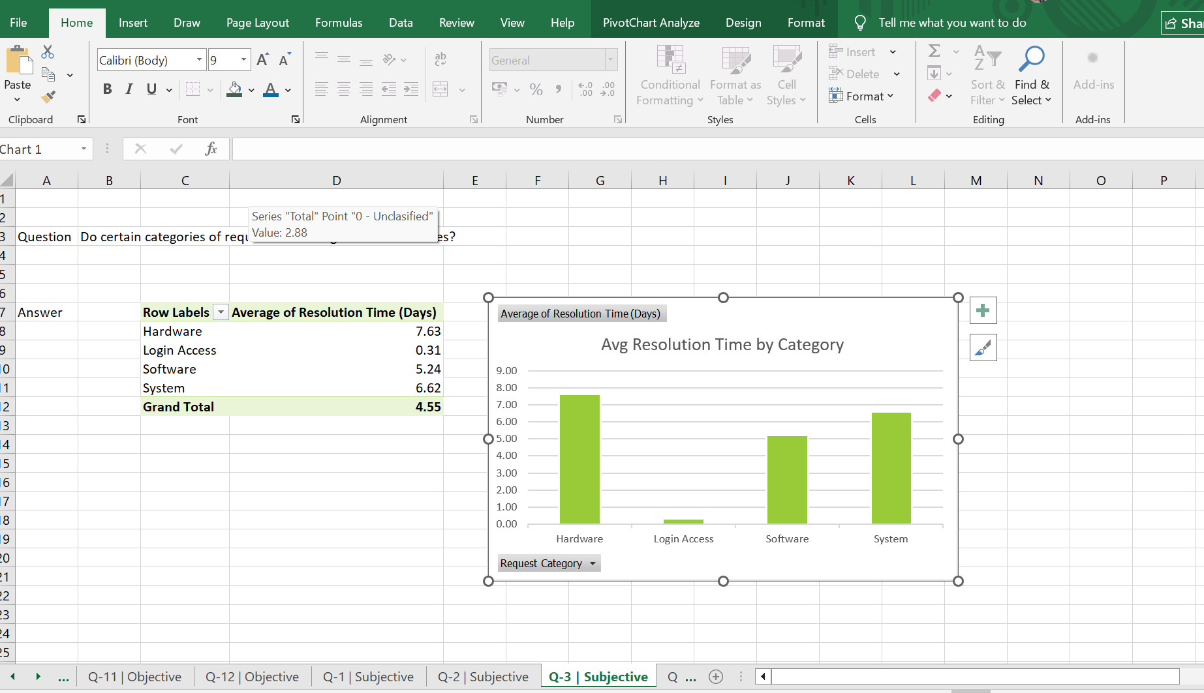

- Description:
The table and bar chart show the average number of days required to resolve tickets for each request category. This helps in visually comparing which categories are more time-consuming.
Insights:
Hardware requests (7.63 days) take the longest time to resolve.
System issues (6.62 days) also require a high-resolution time.
Login Access issues (0.31 days) are resolved very quickly. This clearly indicates that complex technical issues take more time, while routine issues are handled faster.
Recommendations:
Assign experienced agents to handle Hardware and System issues, as they take longer to resolve. Analyze delays in these categories to improve efficiency, automate simple tasks such as login access requests, and provide targeted training to handle complex issues fast.

Question 4: How effective are the current software tools in managing IT tickets?

Analysis: Evaluate performance metrics before and after the implementation of new tools.

Solution:

Approach:
As there is no direct data showing performance before and after implementing software tools, I analyzed overall trends using pivot table. I compared ticket volume, avg resolution time satisfaction rate over years to find how effective are the current software tools in managing tickets.
Charts & Tables:
- Table / Chart Name:
Year-wise Ticket Volume, Resolution Time & Satisfaction

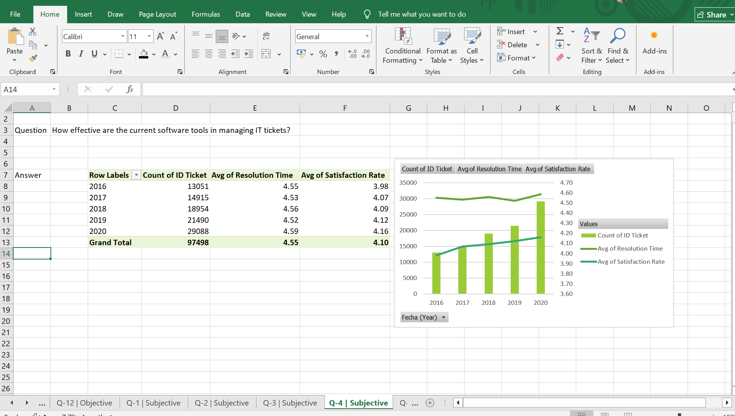

- Description:
Table and chart show how ticket count, resolution time, and satisfaction have changed from 2016 to 2020, giving a complete view of system performance over time.
Insights:
Ticket volume increased a lot from 13,051 to 29,088 showing higher demand for it support. satisfaction also improved from 3.98 to 4.16 service quality is also got better. And resolution time is almost stable around 4.5 though tickets doubled.
Recommendations:
As ticket volume is increasing it’s hard to handle things manually so we need better tools to solve issues faster and reduce resolution time. Using chatbots can help handle simple problems quickly, improving the ticketing system with features like automatic assignment can make the process smoother and reduce delays.

Question 5: How has the performance of the IT support team changed over time (e.g., monthly or quarterly)?

Analysis: Trend analysis using time series charts.

Solution:

Approach:
To understand how the IT support team’s performance has changed over time, I performed a time-series analysis. I grouped the data by year and quarter in pivot table so I could observe trends clearly across different time periods rather than looking at overall averages. I focused mainly on three key metrics: ticket volume to understand about workload, avg resolution time for efficiency, satisfaction rate to for quality. Then I used a combination chart to visualize these metrics together, which helped me compare how performance changes with workload over time.
Charts & Tables:
- Table / Chart Name:
IT Support Performance/ IT Support Performance Trend

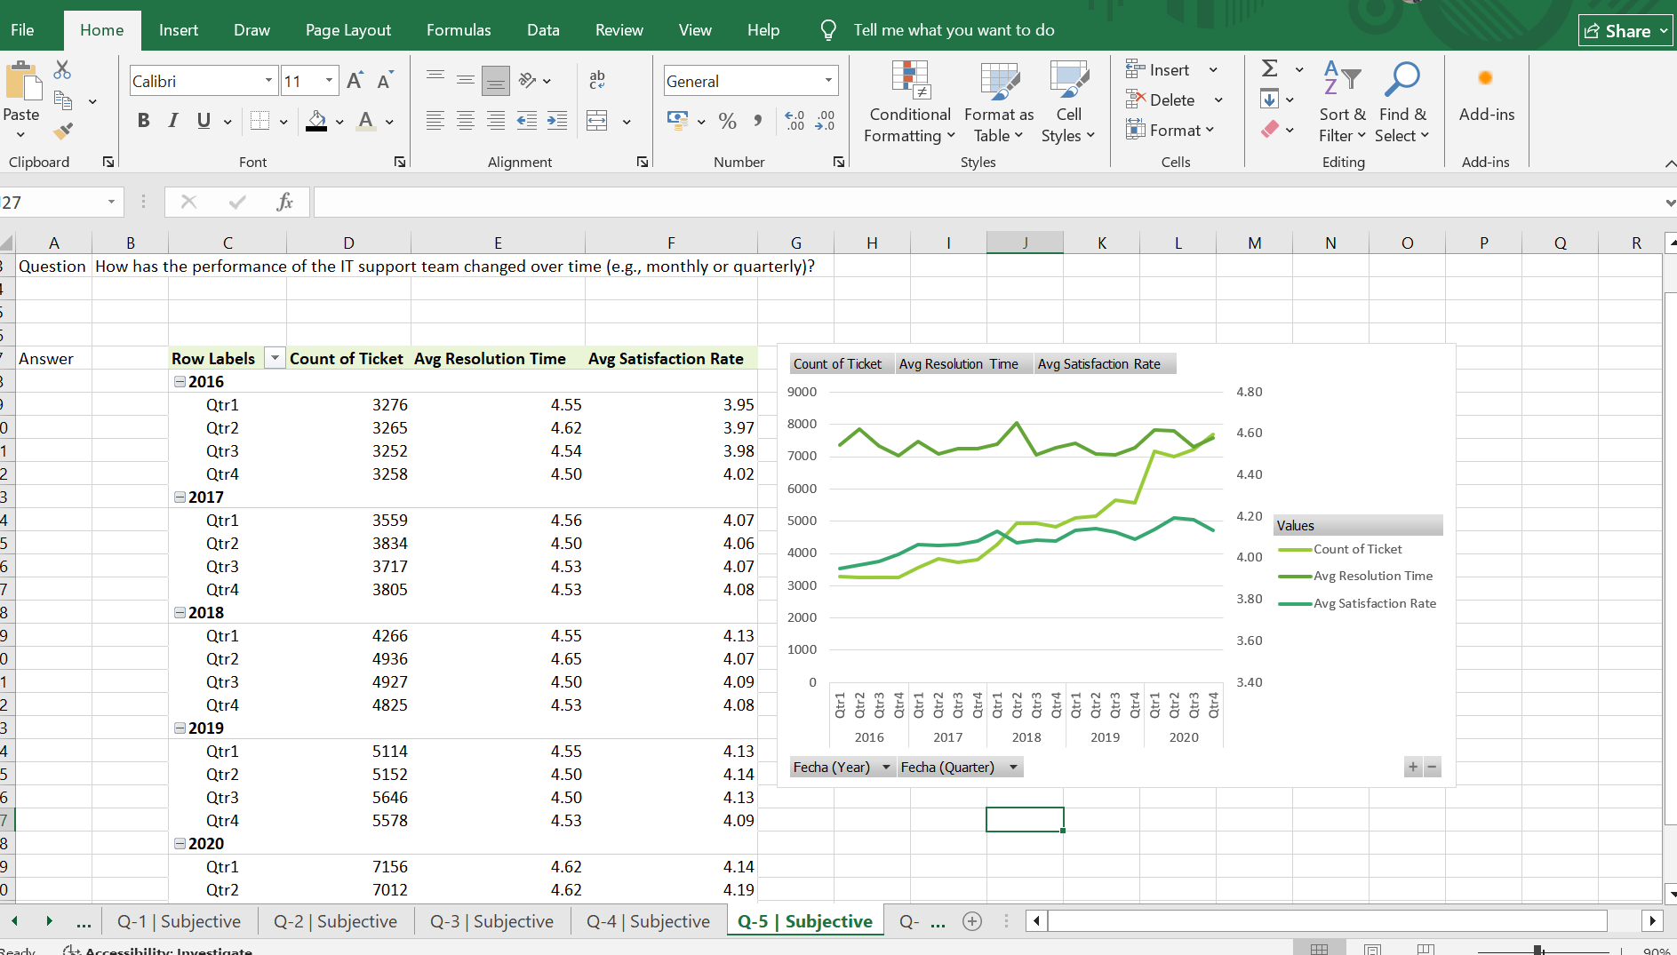

- Description:
Table shows a detailed quarterly breakdown of tickets, resolution time, and satisfaction levels and chart helped me clearly to see how these metrics change over time and how they are related to each other.
Insights:
I observed that ticket volume has been increasing over time, indicating higher demand for IT support. Despite this, resolution time remains mostly stable, showing efficient handling of workload. satisfaction rate also increased gradually. However, during peak periods, there is a slight increase in resolution time, indicating some pressure. Overall team shows good consistency and adaptability over time.
Recommendations:
I will suggest to increasing team capacity and use automation to handle rising ticket volume. Improving prioritization and workflow can reduce delays during peak period. I also suggest to monitor satisfaction rating and past trends for better planning, along with regular training to improve the performance.

Question 6: If we invest more on tech (Hardware, software, etc), do you think it will improve the ticket resolution times and employee satisfaction?

Analysis: Use historical data to project potential improvements.

Solution:

Approach:
To check if investing in technology improves performance, I analyzed monthly resolution time and satisfaction trends. The idea is simple if technology helps, resolution time should decrease and satisfaction should increase over time.
Charts & Tables:
- Table / Chart Name:
Monthly resolution trend
Monthly satisfaction trend

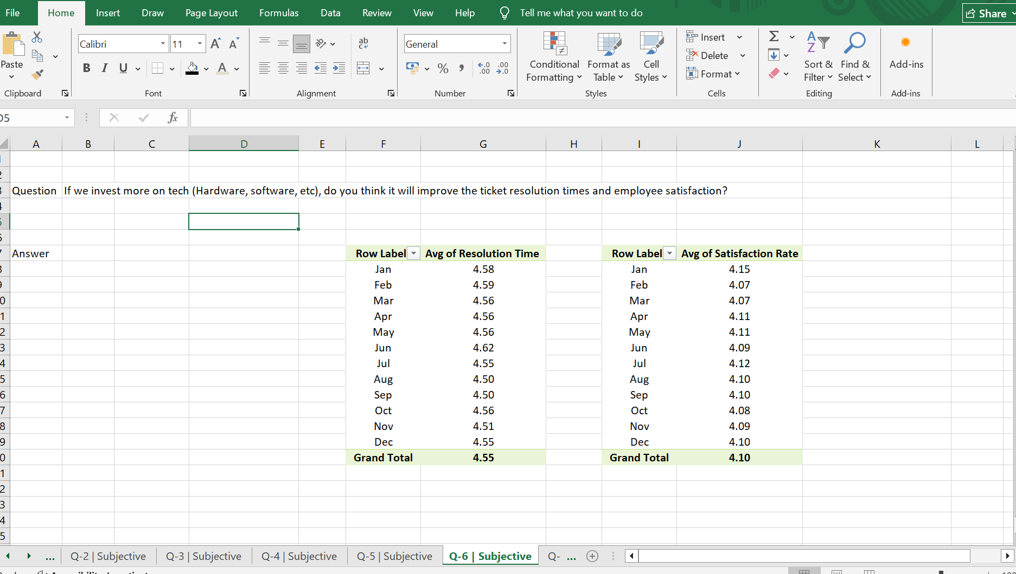

- Description:
Monthly Resolution trend table shows that avg resolution time remains almost constant between 4.50 to 4.62 days showing no major improvement over time.
Monthly satisfaction trend table shows that satisfaction rate stays stable between 4.07 to 4.15 staying consistent.
Insights:
Resolution time stays almost same and satisfaction is also stable so there is no real improvement over time. since resolution time is not decreasing, it shows that efficiency is not improving meaning current technology is not helping much, satisfaction levels are also ok but not increasing. Months with slightly higher resolution shows stable satisfaction means faster service helps maintain user satisfaction. current systems are just enough to maintain this performance, but not strong enough to improve performance.
Recommendations:
Performance is stable but not improving so investing in better technology is important. Faster systems, improved tools, automation will help reduce resolution time and make work easier for agents. After implementing changes, it is also important to track performance to observe improvement.

Question 7: What are the key performance metrics for IT agents, and how can they be improved, do we need to fire any agents?

Analysis: Define and analyze metrics such as average handling time, satisfaction scores, and number of tickets resolved.

Solution:

Approach:
pivot table was created with agent names in rows and avg resolution time, avg satisfaction rate and count of tickets metrics as values which helped compare all agents easily and identify top and low performers.
Charts & Tables:
- Table / Chart Name:
Agent performance summary

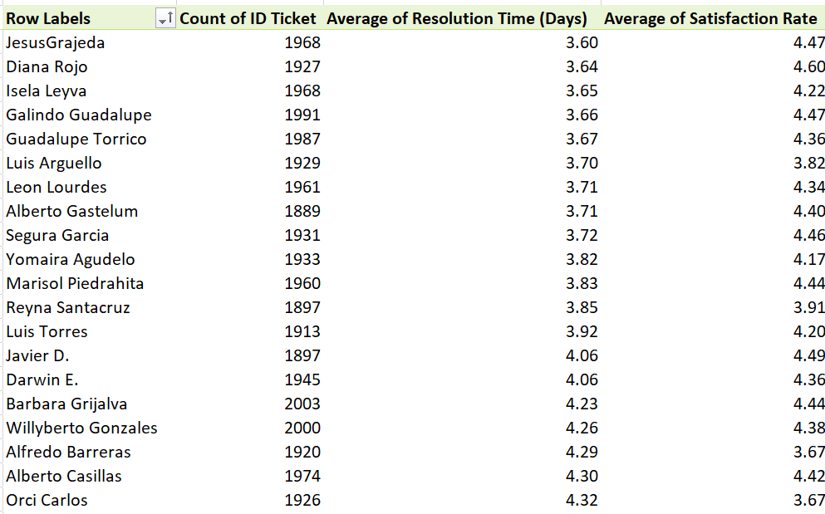

- Description:
The pivot table shows each agent’s performance based on no of tickets handled, avg resolution time, avg satisfaction rate. This provides us combined view of productivity, efficiency and quality making it easy to evaluate overall performance.
Insights:
Avg resolution time is 4.55 days and satisfaction is 4.10, which helps compare agents. Some agents like Diana Rojo perform very well with speed and quality, while other agents like Alfonso Barraza and A. Trejo need improvement. since workload is almost same for everyone but difference comes from skills. some agents are fast but low in quality, and others are slow but better in service.
Recommendations:
There is no need to fire any agents as performance issues are mainly due to skill gaps. Training should be provided to improve efficiency. simple performance targets can help in monitoring, focusing on both speed and quality will improve results. with proper training and monitoring agent performance can be improved without firing anyone.

Question 8: How do employee demographics (e.g., department, seniority) impact satisfaction and ticket outcomes?

Analysis: Segment analysis using filters and pivot tables.

Solution:

Approach:
I used pivot tables to check how age and severity affect satisfaction. A detailed demographic data like department or experience level is not available, I tried to use age as a basic factor and compared it with average satisfaction rate. I also analysed satisfaction with different severity levels.
Charts & Tables:
- Table / Chart Name:
Age vs Satisfaction; Severity vs Satisfaction
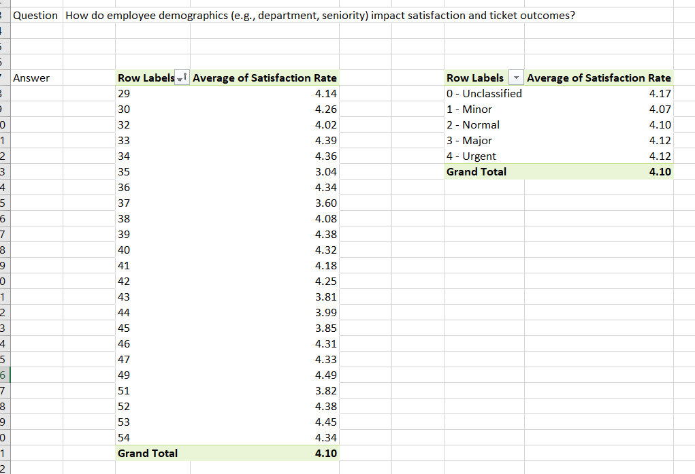
- Description:
Age vs satisfaction table shows average satisfaction score for different ages and severity vs satisfaction table shows how satisfaction changes for severity level.
Insights:
Satisfaction is mostly 4.0-4.4 for all ages, so age doesn’t really affect it much. Only in few cases like age 35 and 37 show lower rating. And for severity minor tickets have a bit lower satisfaction, while other levels are having slightly higher value, but the difference is very small. But, both age and severity don’t impact satisfaction much, and the system is quite consistent.
Recommendations:
Since age doesn’t affect satisfaction much, focus should be on improving the overall processes instead of demographics. Also we have seen cases where satisfaction is slightly low we have to fix them. Keeping service quality consistent all time will help maintain good satisfaction levels.

Question 9: Identify the trends for IT support operations based on ticket volumes and satisfaction, and mention the peak and stable times?

Analysis: Use pivot tables and charts to identify peak and off-peak hours.

Solution:

Approach:
I analyzed data using pivot table and chart by taking month and year from the date. I evaluated two metrics ticket volume and average satisfaction rate (to assess service quality). By comparing these metrics over time, I identified patterns that indicate peak and stable periods.
Charts & Tables:
- Table / Chart Name:
Monthly ticket volume & Satisfaction trend
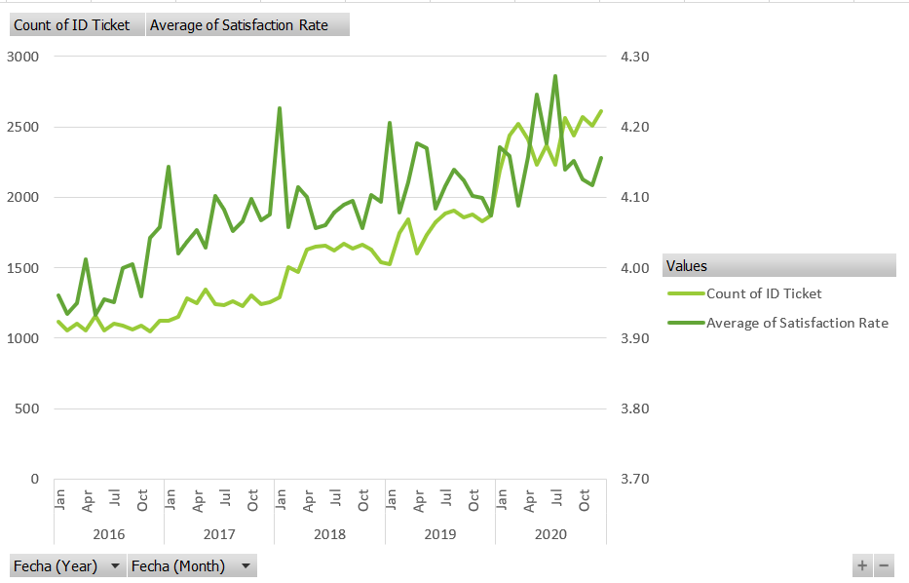

- Description:
Table and corresponding line chart display how ticket volumes and satisfaction levels change month by month across multiple years, helping to visually identify fluctuations and patterns in operations
Insights:
Ticket volume has steadily increased from 1050–1150 in 2016 to 2400–2600 in 2020, showing rising demand for IT support. The highest workload is seen in 2020, especially in Aug, Oct, and Dec. 2016 and early 2017 showed more stable and manageable ticket volumes. Despite the growth in tickets, satisfaction remains consistently around 4.0–4.2, with only slight dips during peak periods.
Recommendations:
Ticket volume is higher in months Mar, Aug, Oct, and Dec, so more staff or better shift planning is needed during this time. And finding why tickets increase in these months can help prevent issues earlier.

Question 10: What metrics should be included in the final dashboard to provide a comprehensive view of call center performance and guide investment decisions?

Solution:

Approach:
To design a comprehensive call centre dashboard, I focused on combining efficiency, satisfaction rate, workload trends, agent performance.
The methodology included:
Using Pivot Tables to aggregate KPIs (tickets, resolution time, satisfaction), creating time-based trends on month and year to track performance changes, segmenting data by category, severity, issue type and agents. Ensuring that the dashboard supports decision-making like hiring, training, tools investment etc.
Charts & Tables:
- Table / Chart Name:
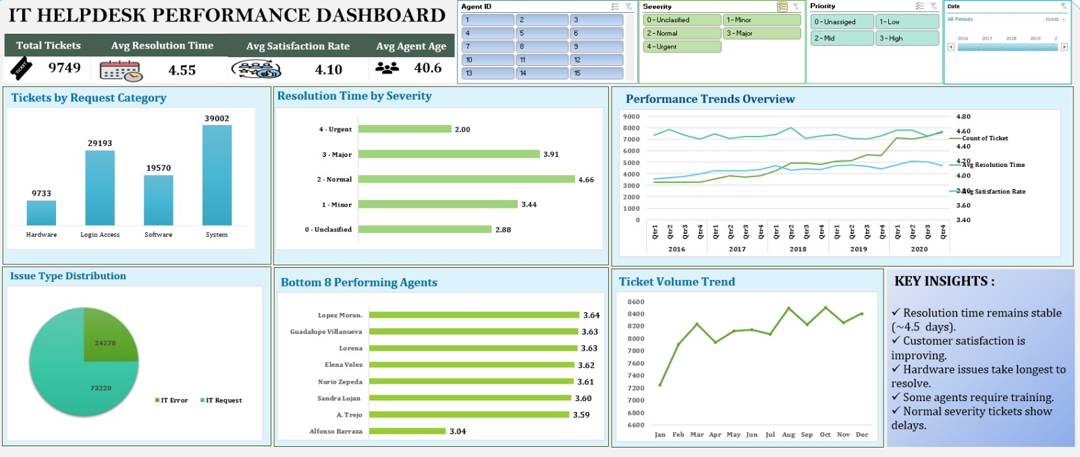

- Description:
The dashboard provides a complete overview of IT support performance, helping understand how efficiently the team is handling tickets and where improvements are needed.
Insights:
Ticket volume is increasing, showing growing demand for IT support. Resolution time remains stable at around 4.5 days, indicating consistent efficiency, while customer satisfaction is gradually improving. System and Login issues dominate the workload, and hardware issues take the longest to resolve. Normal severity tickets show delays. Agent performance varies, with some agents needing training.
Recommendations:
To improve the performance the organization should invest in technology to handle the increasing ticket volume and reduce the delays. Training should be given for the underperforming agents and should be more focused on improving hardware issue resolution. And ticket prioritization should be done more efficiently.

